**THE SUPERIOR COLLEGE LAHORE**

|  |
| --- |
|  |

**Faculty of Computer Science & IT**

**FINAL YEAR PROJECT**

**PROJECT PROPOSAL& PLAN**

**[Citizen Health Portal]**

Project ID:**[Issued by FYP Manager]**

**Project Team**

|  |  |  |  |  |
| --- | --- | --- | --- | --- |
| **Student Name** | **Student ID** | **Program** | **Contact Number** | **Email Address** |
| Asad Ali Rana | Bcsm-s17-036 | BSCS | 0306-5366036 | [Asadalirana62@gmail.com](mailto:Asadalirana62@gmail.com) |
| M Hamza | Bcsm-s17-028 | BSCS | 0313-4645610 | [Bcsm-s17-028@superior.edu.pk](mailto:Bcsm-s17-028@superior.edu.pk) |
| M Farooq Usman | Bcsm-s17-031 | BSCS | 0302-5354709 | [Bcsm-s17-031@superior.edu.pk](mailto:Bcsm-s17-031@superior.edu.pk) |
|  |  |  |  |  |
|  |  |  |  |  |

**[Project Supervisor]**

([Designation])

**[Citizen Health Portal]**

**Change Record**

|  |  |  |  |  |
| --- | --- | --- | --- | --- |
| **Author(s)** | **Version** | **Date** | **Notes** | **Supervisor’s Signature** |
|  | 1.0 |  | Original Draft |  |
|  |  |  | Changes Based on Feedback from Supervisor |  |
|  |  |  | Changes Based on Feedback From Faculty |  |
|  |  |  | Added Project Plan |  |
|  |  |  | Changes Based on Feedback from Supervisor |  |
|  |  |  |  |  |
|  |  |  |  |  |

**Project Proposal**

**Project Title:** Citizen Health Portal

# Executive Summary

In our health department there is not a single hospital that gives easy online access to their patient’s guardian for treatment data. With the rapid development of smart phones and mobile devices, it becomes very popular that people more prefer to access the information through this flexible way. Citizen Health Portal will be an online plate form where all medical facilities will provide through online system. There is an increased emphasis on patients taking a more active role in managing their health information, which has been associated with better clinical outcomes and patient empowerment.

CITIZEN Health PORTAL will help healthcare facilities and provides a technology that supports patient and doctor, access to the patient’s health information. Our aim is to move the Pakistan towards a more patient focused health care system where there is collaboration between the Patient and the Doctor. This way we can improve the quality and safety of healthcare, decrease costs, and patient satisfaction increases.

# Introduction

Currently in most medical, Health care and diagnose centers manual system is used for maintenance of information of their patients. Some of them have their own systems to maintain their patient’s data. Rapidly growing use of technologies has increased pressure on the demand for online based data collection solutions to bridge the information gaps in the health sector of the developing world. Main purpose to develop this system is to help those people who got injured in any road accident or any other mishaps, most of them lose their life because they have some genetic disease like diabetes, blood pressure or other severe disease but in emergency (accident) they are treated as normal person because doctor had no previous medical history of that patient. So to overcome this problem Citizen Health Portal will help to maintain the all previous record of the patient that can be accessed by any doctor as per need in case of emergency.

1. **Existing System / Competitive Analysis**

There is no such solution in Pakistan which provides such all services in health care department. There is NO system or Portal in Pakistan who meets our functionalities. Some hospitals have their own portals but that portal access is only for Doctors or Admin staff in their own hospital. Like Doctor Hospital and Mid City Hospital Lahore.

* **Health Wire**
* **E-NovatRX**
* **doctHERs**

1. **Problem Statement**

## The main problem is coordination and quality of patient health care. Currently in most medical centers manual system is used for the management and maintenance of information. The current system requires numerous paper works. It is difficult to manage manual record. If someone is visiting a doctor for consultation he/she needs to be physically present at the hospital/clinic and wait until doctor is available. Patients had to take the overhead for searching of suitable doctors, hospitals, pharmacies, laboratories and blood banks

## Proposed Solution

This project is all about the technology awareness of the local civilians of Pakistan for Health Care. As currently there is no single such system working in Pakistan for Health Care. This Portal will control healthcare and benefit costs while engaging Patients with interactive tools to improve their personal health and wellness. This portal will help patients by keeping their medical history stored online so they don’t have to carry their medical documents with them to doctor and you can visit any doctor in the country and he/she can access your medical history online. All government and private sector hospitals, clinics, laboratories will be registered and the medical data of every citizen will be kept on our database.

1. **Scope of the Project**

The scope of Citizen Health Portal is extended beyond its conventional boundaries. It means both in geographical and conceptual sense; portal enables Patient to easily obtain health services online. One of the main objectives of Citizen Health Portal is to increase efficiency in health care, thereby decreasing costs by avoiding duplicative or unnecessary diagnostic or therapeutic interventions, through enhanced communication possibilities between doctors and through patient involvement.

1. **System Architectural Design**

* Hardware Domain hosting server.
* Pc /laptop’s Software
* Web Browser

1. **Implementation Tools and Techniques**

* Xampp Server.
* Sql database.
* PHP editor for back end.
* HTML & CSS for front end
* Photoshop for designing templates.
* Prototyping Tools

1. **Project Plan**

The project plan is illustrated in the WBS, Roles and Responsibility Matrix and Gantt Chart.

* 1. **Work Breakdown Structure**

# WBS.png

# Roles & Responsibility Matrix:

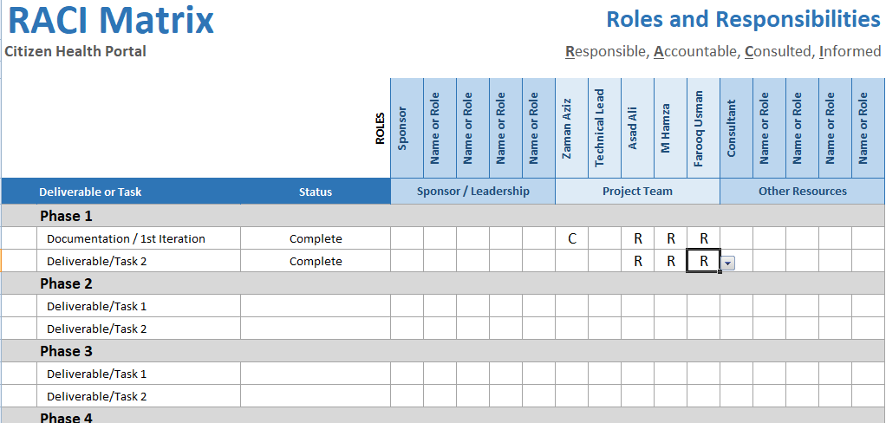

* 1. **Gantt Chart**

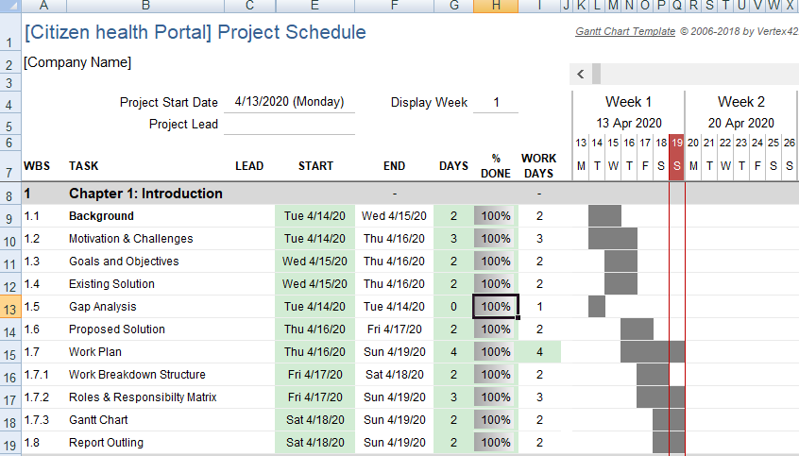

**References**

[12 pt, Calibri, Justified]

[*Give references to the resources you have consulted in finalizing your project topic.*]

**List of Faculty Proposed Changes**

**Project Title**

|  |  |  |
| --- | --- | --- |
| **Proposed Change** | **Proposed By** | **Supervisor’s Decision** |
|  | Name of Faculty Member(s) who proposed this change | Approved/Disapproved and/or Comments |
|  |  |  |
|  |  |  |
|  |  |  |
|  |  |  |
|  |  |  |
|  |  |  |

**Date: __________________ Supervisor’s Signature: ______________**

**APPROVAL**

|  |  |
| --- | --- |
| **Project Supervisor** | |
| Comments: ___________________________________________________________________ | | |
| _____________________________________________________________________________ | | |
| _____________________________________________________________________________ | | |
| _____________________________________________________________________________ | | |
| Name:______________________________ |  | |
| Date:_______________________________ | Signature:__________________________ | |

|  |  |
| --- | --- |
| **Project Manager** | |
| Comments: ___________________________________________________________________ | |
| _____________________________________________________________________________ | |
| _____________________________________________________________________________ | |
| _____________________________________________________________________________ | |
| _____________________________________________________________________________ | |
|  |  |
| Date:_______________________________ | Signature:__________________________ |